**Version: apache-commons-configuration2-2.7 SLOC:150647**

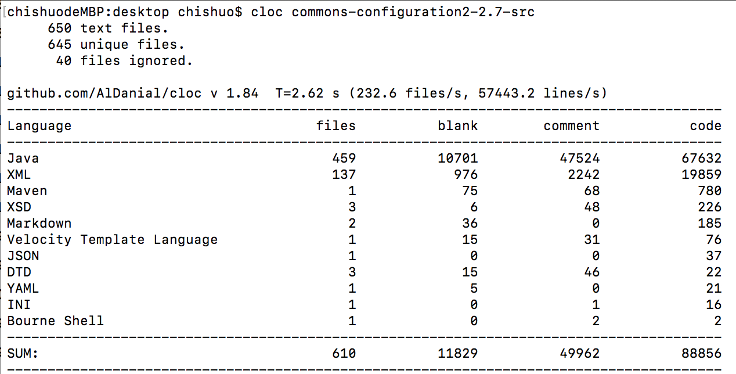

**Version: apache-commons-configuration2-2.6 SLOC:153810**

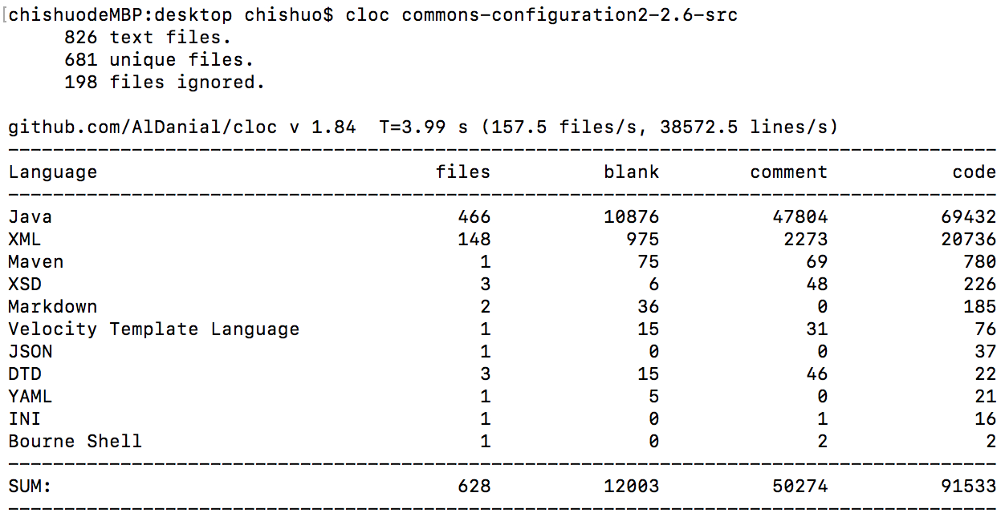

**Version: apache-commons-configuration2-2.5 SLOC:166814**

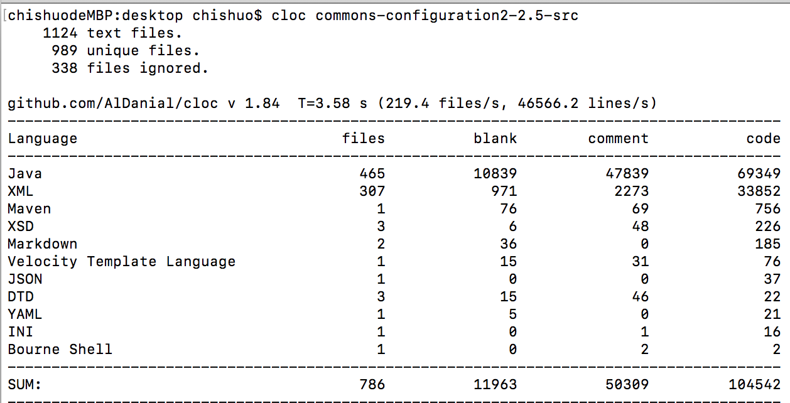

**Version: apache-commons-configuration2-2.4 SLOC:166968**

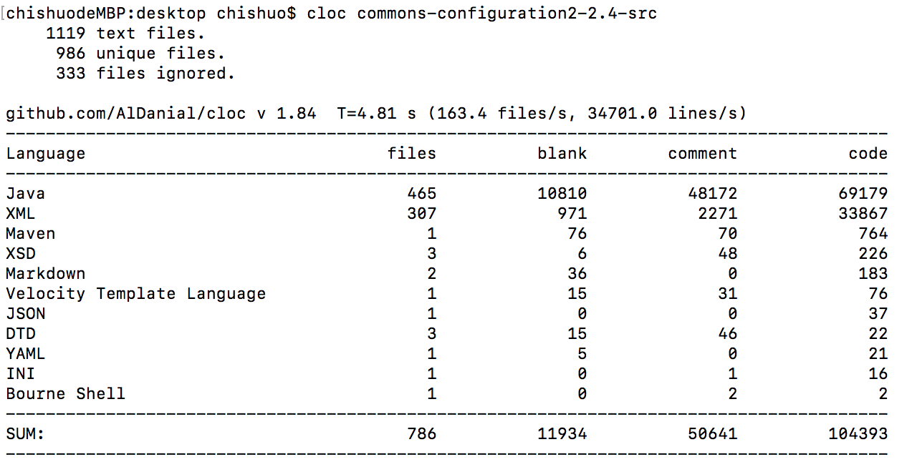

**Version: apache-commons-configuration2-2.3 SLOC:166216**

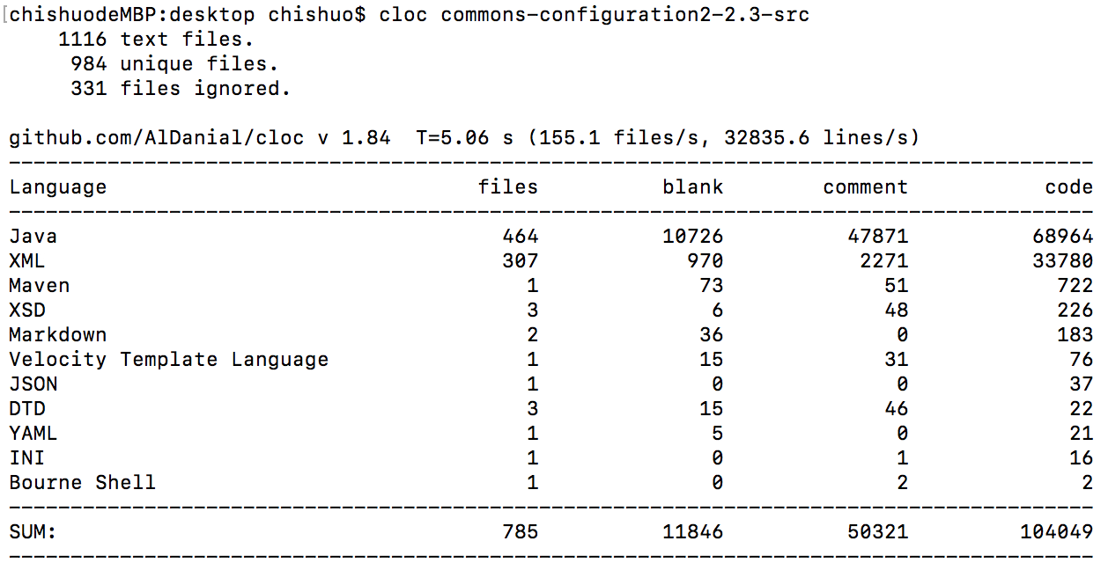

* **Website:** <http://commons.apache.org/configuration/>
* **Bug-tracking:** <http://issues.apache.org/jira/browse/CONFIGURATION>
* **Subversion repository:** <http://svn.apache.org/repos/asf/commons/proper/configuration>